Exploring Playtyne
Why not use some of the equipment in this bag to help you explore Playtyne?
What can you catch using this net?

Can you measure how big the object is that you have caught?

Can you catch something smaller?
Exploring Playtyne
Why not use some of the equipment in this bag to help you explore Playtyne?
Can you take all the sails off the boats? Keep the sails but put all the boats into the river. Choose a coloured sail, what shape is on the bottom? Can you find the right boat that it fits on?
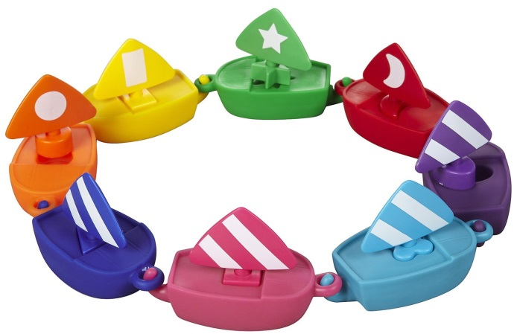

Can you take all the shells off the turtles? Keep the shells but put all the turtles into the river. Choose a coloured shell, what shape is the hole? Can you find the right turtle that it fits on?
