Toys in the Past 

**Can you find the following toys in the Newcastle Story gallery on the ground floor and discuss:**

• What material is the toy made from?

• Is it an old or a new toy?

• How do you think you might play with this toy?

• Who do you think might play with this toy?

• Do we still play with toys like this today?

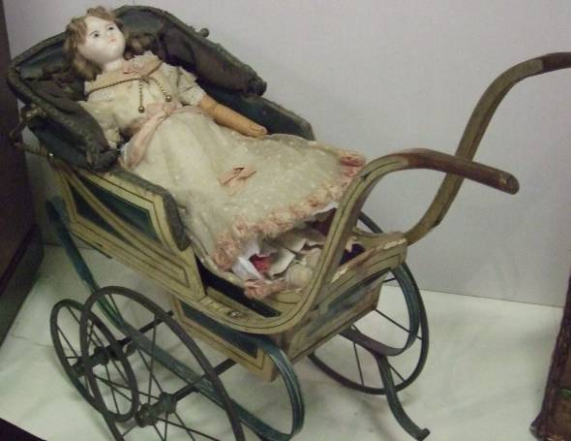

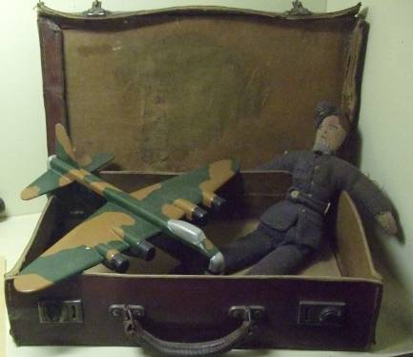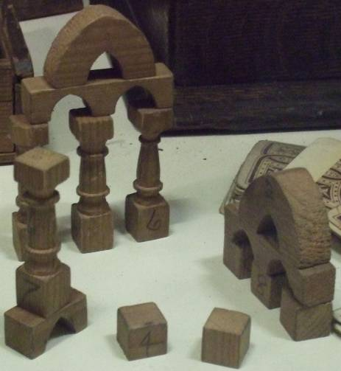

Look for these toys in the 1940’s section.

Look in the Victorian section for these three toys.

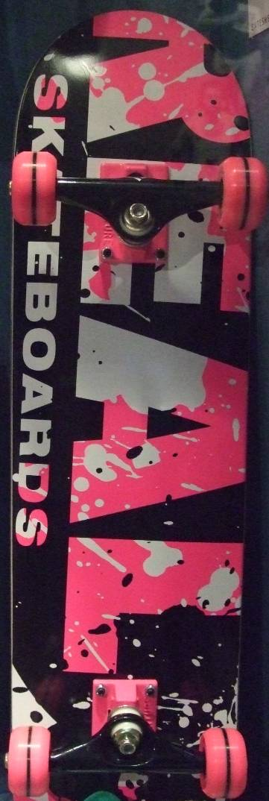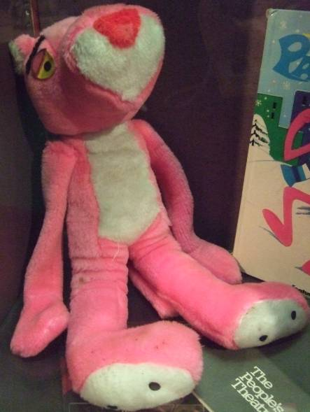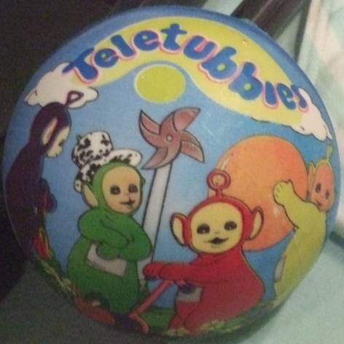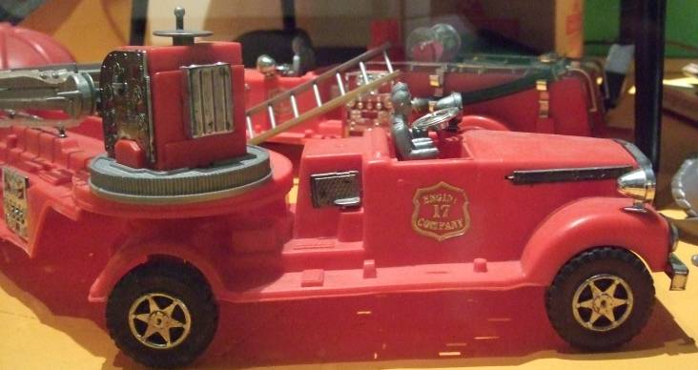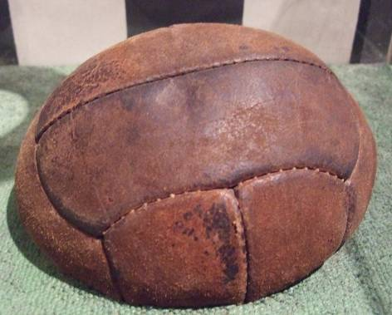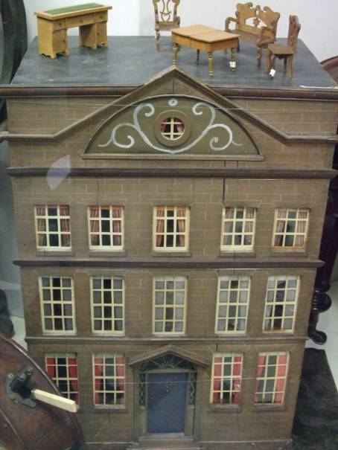

All these toys were made after 1950. Can you find them in the gallery and answer the questions on the previous page.

After looking at all these different toys what different kinds of materials can toys be made from?

What are the differences between toys from the past and the ones you have at home?