Bridges over the River Tyne
Newcastle Story- Ground floor
Can you find the Medieval Tyne Bridge?
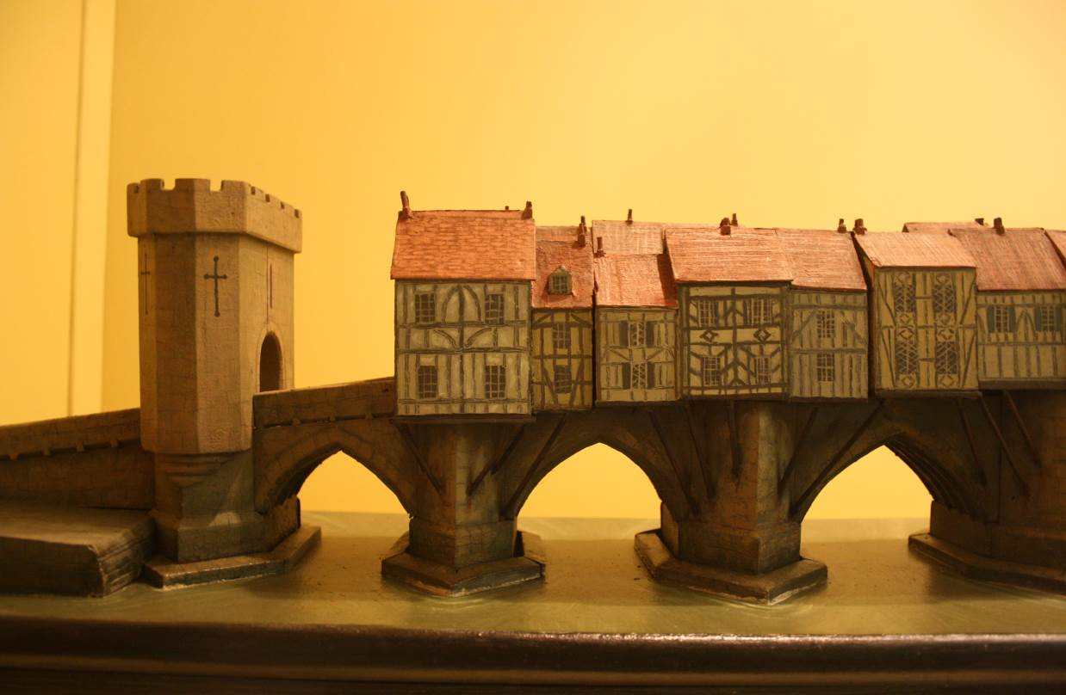
Materials
What materials are bridges made from?
Make a list as you look at the bridges in the museum.

What can you see on the bridge?

Can you find out what happened to the bridge?

What do you think it would be like to live on a bridge?

Can you find the painting of the Georgian Tyne Bridge?
Shapes
Bridges come in all shapes and sizes. What shapes can you see in the bridges around the museum?
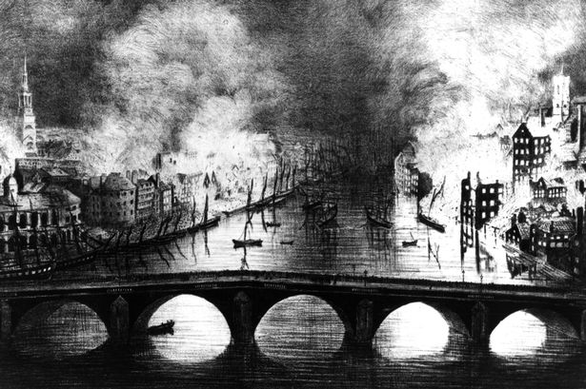

How is this bridge different from the Medieval Tyne
bridge?

What do you think is happening in Newcastle and
Gateshead in the painting?

Story of the Tyne- 1st Floor

Can you find the golden Swing Bridge model?

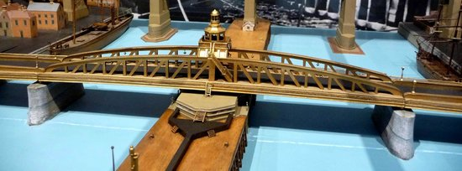
The Swing Bridge was built to replace the Georgian Tyne Bridge. Is this bridge better or worse? Why?

What type of engine did the Swing Bridge use to move?
(hint: look at the green engine to the left)

Who invented the swing bridge? What else did he invent?

What is the name of the other bridge in the case?

What is special about this bridge?

Can you find the map of the River Tyne?

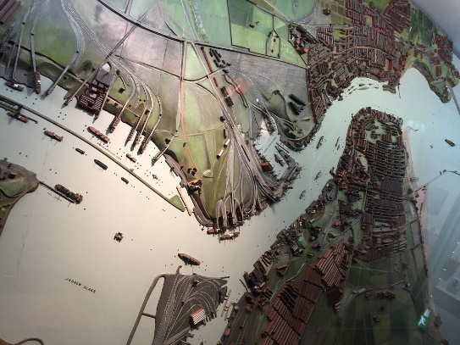
How many bridges can you see on it?

How would you get across the river between North Shields and South Shields?

Are there any bridges missing? Why?

What other landmarks can you see?

Tyneside Challenge- 1st floor
Can you find the model of the Tyne Bridge?
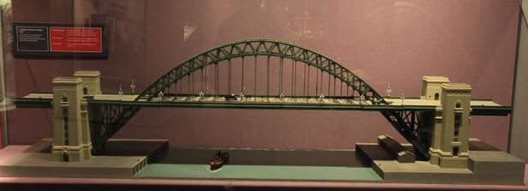

What shape is this bridge?

Where would you start building a bridge like this?

Can you find out 3 facts about this bridge?

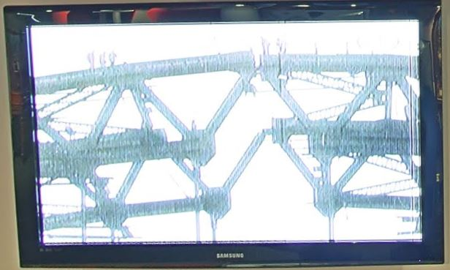

What two bridges can you see getting built in this film?

What equipment are they using to build the bridges?

How do you think the workers would have felt when they were building the bridges?

