World War II
Newcastle Story- Ground floor
Can you find the air raid shelter in the 1940’s room? Do you know what type of shelter it is?

How many people do you think would fit inside?
Enigma- Ground floor

The Enigma machine is a cipher machine that was used during WW2 by the German military to encrypt messages. It turned messages into secret code.

How many bombs were dropped in Newcastle during WW2?

Manors Goods Station suffered damage during an air raid on the 1st of September 1941. What did the station smell like for days after?
How many combinations can a 3-rotor enigma generate to encode a single line of text?

What is the name of the ship that was instrumental in breaking the enigma code?

Where was the ship built?

What is the name of the canteen assistant that helped to secure the code books from the German U-boat?
How many volunteers did the Air Raid Precaution have at its peak?

Fire Guards watched important buildings 24 hours a day during WW2. What age could women called up to be fire guards?

During WW2 40,000 children were evacuated to safe places in the countryside. What would you pack in your suitcase if you were evacuated?

1st Floor: Charge!
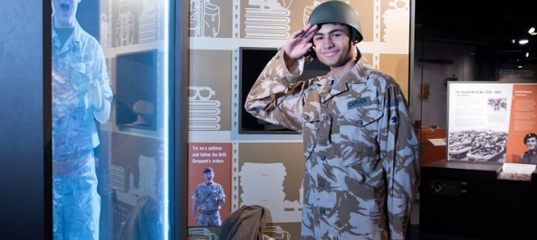
Can you find Lieutenant Gale’s case?
What was kept inside the case?

On D-Day the 13th and 18th Hussars were the only regiment to land on the beaches in what type of vehicle?

Where were the Northumberland Hussars sent to fight during WW2?

What Medals did Evelyn Pike receive for her service during WW2?

1st Floor: Tyneside Challenge

Which Tyneside armaments manufacturer made weapons used during WW2?

During World War 2 the factories on Tyneside were booming but fresh food was very scarce. Can you find the type of tinned food imported from America?

1st Floor: Story of the Tyne
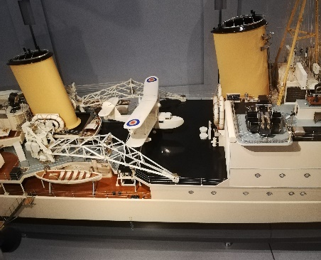
Can you find the HMS Manchester?
Use the screen to find out more information about the ship.
Who built the HMS Manchester?

Where did she serve during WW2?

What happened to the ship in Tunisia during WW2?

